Thursday 4th June, 2025

Dear Parents/Carers,

**Dear Parents and Carers,**

**Ref: KS2 Sports Day**

On **Tuesday, 17th June**, KS2 will be having Sports Day at Brockwell Park, to support their PE curriculum.

Please see the map below for where the Sports Day will take place. It is the same as last year.

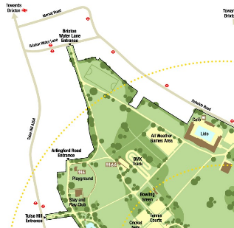

The children should all come to school as usual at 8:50am on Tuesday morning, wearing a T-shirt in the colour of their house, PE shorts and trainers. All children should also have their tracksuit bottoms and a waterproof coat in case of bad weather. They will also need a packed lunch, including two sealable drinks and should therefore bring a backpack/ bag in which they can carry these items. Please also ensure your child has a hat to protect them from the sun, sunscreen, if needed, and enough drinking water.

As there are so many children travelling to the venue, we would appreciate some support with supervising their travel to Brockwell Park. We will be leaving school shortly after 9:30am in staggered groups.

Class teachers will accompany the children on this trip. If you would like to volunteer to accompany the children on the walk to Brockwell Park, please indicate this via BJS Federation Parent App (Weduc). We will let you know whether you are able to come along on this occasion.

Children will require a packed lunch as this will be a full day visit. Packed lunches brought from home should contain a selection of healthy food and no glass bottles. If you require a packed lunch provided by the school, please inform the school by Monday 9th June using BJS Federation Parent App (Weduc). The school will not provide a lunch unless it has been ordered and children who do not have a packed lunch will not be able to attend the trip.

Please use BJS Federation Parent App (Weduc)to give consent for your child to take part in the trip.

Yours faithfully,

Mr Hirsch

Year 4 Class Teacher and PE lead.